Design Patterns and Principles

Exercise 1: Implementing the Singleton Pattern

public class Logger{

    private static Logger instance; // creating private static variable

    private Logger(){ // private constructor

        System.out.println("Singleton instance created");

    }

    public static Logger getInstance(){ // static function

        if(instance==null){

            instance= new Logger();

        }

        return instance;

    }

    public void log(String s){

        System.out.println(s);

    }

}

public class TestSingleton{ // test class

    public static void main(String[] args) {

        Logger obj1=Logger.getInstance();

        obj1.log("First log");

        Logger obj2=Logger.getInstance();

        obj2.log("Second log");

        System.out.println(obj1.hashCode());

        System.out.println(obj2.hashCode());

        System.out.println(obj1==obj2);

    }

}

OUTPUT:

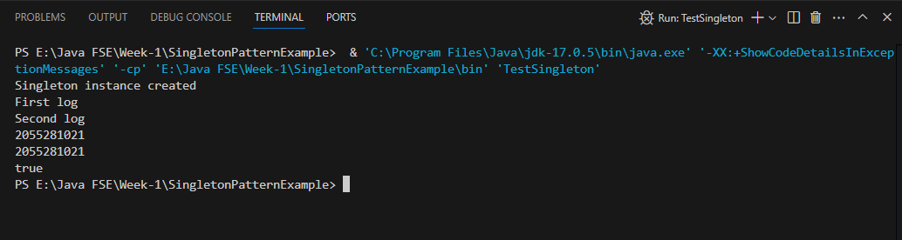

Exercise 2: Implementing the Factory Method Pattern

public interface Document { // interface

    String print();

}

public class ExcelDocument implements Document{

     public String print(){

        return "It is a Excel Document";

    }

}

public class PdfDocument implements Document{

    public String print(){

        return "It is a PDF Document";

    }

}

public class WordDocument implements Document {

    public String print(){

        return "It is a Word Document";

    }

}

public abstract class DocumentFactory { // abstract class

    public abstract Document createDocument();

}

public class Excel extends DocumentFactory {

    public Document createDocument(){

        return new ExcelDocument();

    }

}

public class Pdf extends DocumentFactory{

    public Document createDocument(){

        return new PdfDocument();

    }

}

public class Word extends DocumentFactory {

    public Document createDocument(){

        return new WordDocument();

    }

}

public class TestFactory { // test class

public static void main(String[] args) {

    DocumentFactory document=new Word();

    Document word = document.createDocument();

    System.out.println(word.print());

    document=new Pdf();

    Document pdf = document.createDocument();

    System.out.println(pdf.print());

    document=new Excel();

    Document excel = document.createDocument();

    System.out.println(excel.print());

}

}

OUTPUT:

